**L. VARSHINI**

**192372045**

**CSA1618 DWDM**

**EXPERIMENT-23**

**DATA SEGMENTATION BY EXPECTATION MAXIMISATION ALGORITHM THROUGH WEKA**

**AIM:**

To create data segmentation by Expectation Maximisation algorithm through weka.

**PROCEDURE:**

1. Download and install WEKA.
2. Open WEKA and Choose "Explorer" from the main menu.
3. Under Preprocess, Click on the open file button and select the dataset.
4. Click on the "Cluster" tab. In the Cluster mode section, select "Use training set".
5. Click "Choose" (next to the cluster algorithm) and Select EM (under weka. clusters).
6. Click on **"EM"** to configure it: **numClusters (-1 for automatic selection)** → WEKA will automatically determine the optimal number of clusters. **MaxIterations** → Set to 100 (default) or increase for better accuracy. **Seed** → Keep a fixed value (e.g., 10) for reproducibility.
7. Click **"OK"** and then **"Start"** to run the EM clustering. WEKA will display cluster assignments and statistics.
8. Click "Visualize" to see how the clusters are distributed. Save the file.

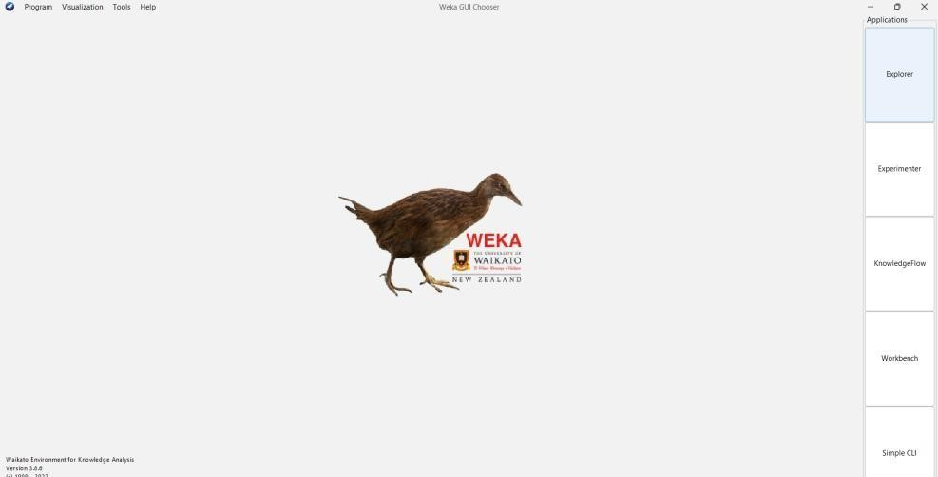

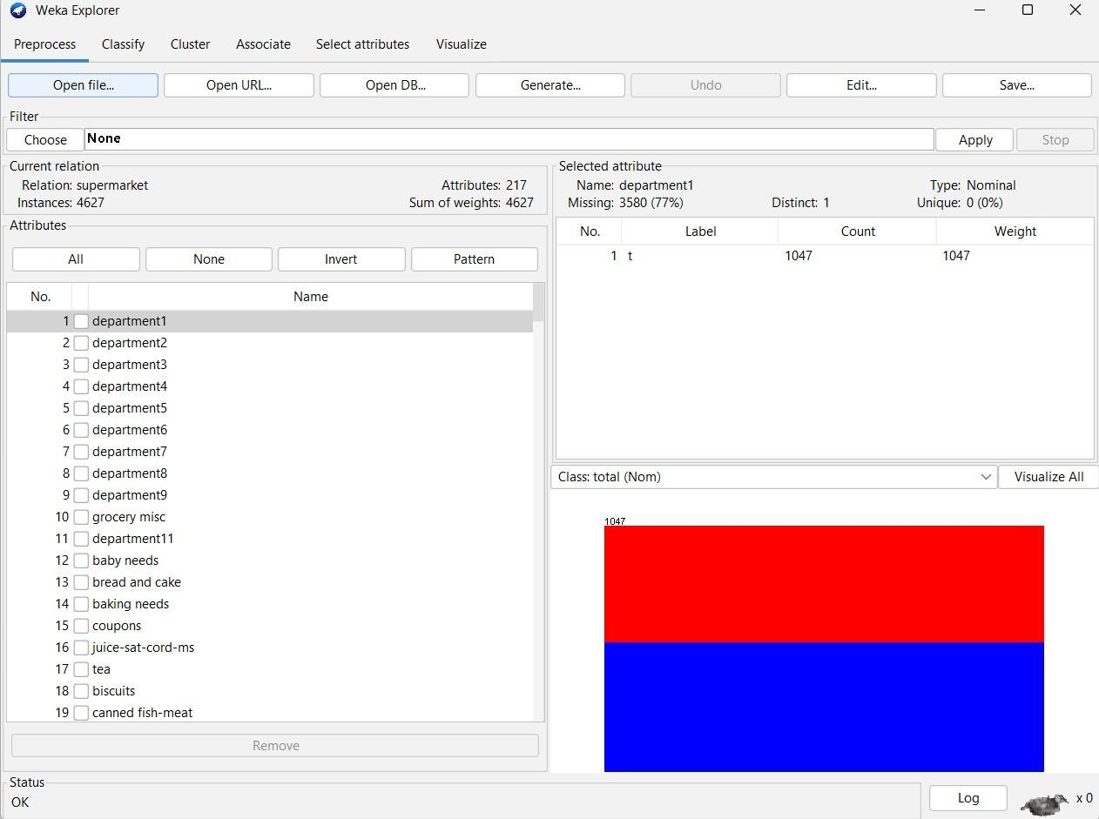

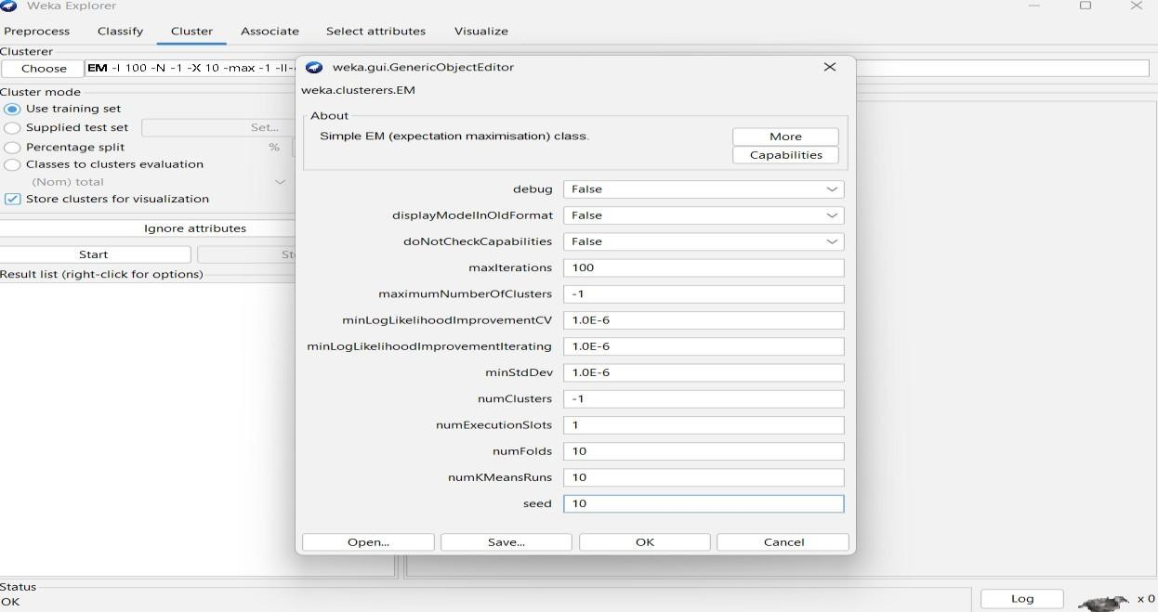

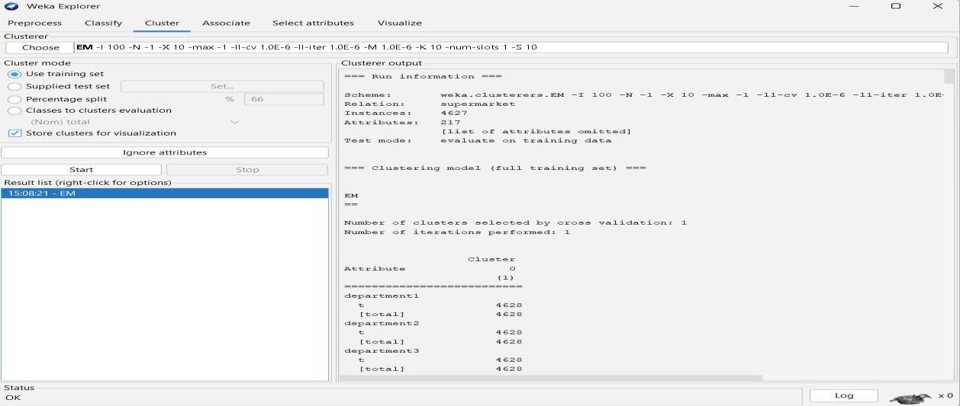

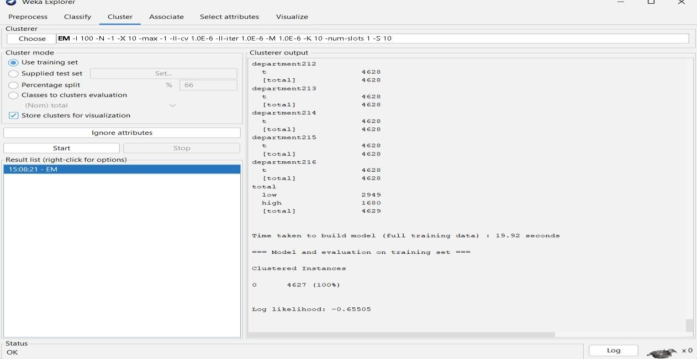

**OBSERVATION:**

Scheme: weka.clusterers.EM -I 100 -N -1 -X 10 -max -1 -ll-cv 1.0E-6 -ll-iter 1.0E-6 -M 1.0E-6 -K

10 -num-slots 1 -S 10

Relation: supermarket

**Instances: 4627**

**Attributes: 217**

[list of attributes omitted]

Test mode: evaluate on training data

=== Clustering model (full training set) ===

EM

==

**Number of clusters selected by cross validation: 1**

**Number of iterations performed: 1**

Cluster

Attribute 0

(1)

========================== department1

t 4628

[total] 4628 department2

t 4628

[total] 4628…………………………

Time taken to build model (full training data) : 19.92 seconds

=== Model and evaluation on training set ===

**Clustered Instances**

**0 4627 (100%)**

**Log likelihood: -0.65505**

**PLOT:**

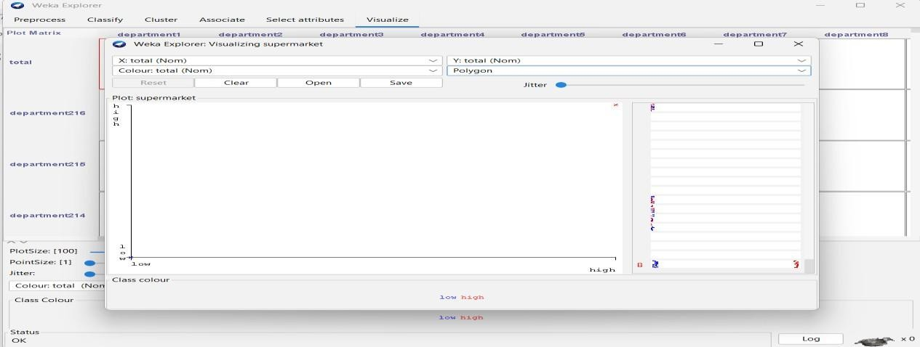

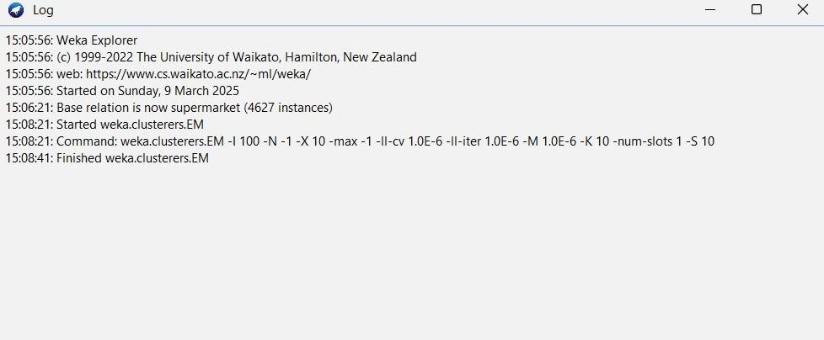

**RESULT:**

Thus, the data analysis by the expectation maximization algorithm using weka has been analyzed and observed properly.